Experiment No. 5
Aim: Implementation of user defined package
1. Implement a package LibraryManagement with classes Book and Member. The Book class should have attributes like title, author, and ISBN, while the Member class should store member details. Use this package to create a simple library system
LibraryProject/
└── LibraryManagement/
├── Book.java
├── Member.java
└── LibraryDemo.java
//Book.java
package LibraryManagement;
public class Book {
private String title;
private String author;
private String isbn;
public Book(String title, String author, String isbn) {
this.title = title;
this.author = author;
this.isbn = isbn;
}
public void displayBook() {
System.out.println("Book Title: " + title);
System.out.println("Author: " + author);
System.out.println("ISBN: " + isbn);
}
}
//Member.java
package LibraryManagement;
public class Member {
private String memberName;
private int memberId;
public Member(String memberName, int memberId) {
this.memberName = memberName;
this.memberId = memberId;
}
public void displayMember() {
System.out.println("Member Name: " + memberName);
System.out.println("Member ID: " + memberId);
}
}

//LibraryDemo.java
package LibraryManagement;
public class LibraryDemo {
public static void main(String[] args) {
Book book1 = new Book("Java Programming", "James Gosling", "ISBN12345");
Member member1 = new Member("Prasanna", 101);
System.out.println("=== Library System ===\n");
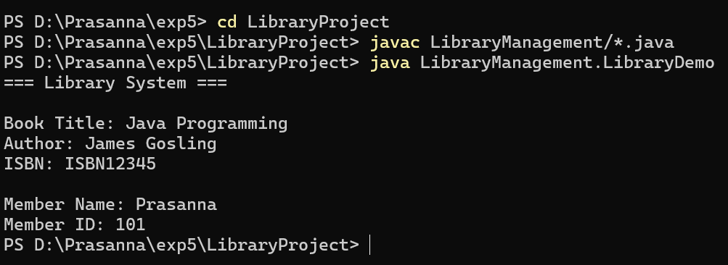
book1.displayBook();
System.out.println();
member1.displayMember();
}
}

2. Create a package Ecommerce containing classes Product, Customer, and Order. Implement methods for placing an order, displaying product details, and calculating total order cost. Use this package in another program
EcommerceProject/
└── Ecommerce/
├── Product.java
├── Customer.java
├── Order.java
└── EcommerceDemo.java
//Product.java
package Ecommerce;
public class Product {
private String name;
private double price;
private String productId;
public Product(String name, double price, String productId) {
this.name = name;
this.price = price;
this.productId = productId;
}
public void displayProduct() {
System.out.println("Product Name: " + name);
System.out.println("Product ID: " + productId);
System.out.println("Price: $" + price);
}
public double getPrice() {
return price;
}
}

//Customer.java
package Ecommerce;
public class Customer {
private String customerName;
private int customerId;
public Customer(String customerName, int customerId) {
this.customerName = customerName;
this.customerId = customerId;
}
public void displayCustomer() {
System.out.println("Customer Name: " + customerName);
System.out.println("Customer ID: " + customerId);
}
}

//Order.java
package Ecommerce;
import java.util.ArrayList;
public class Order {
private Customer customer;
private ArrayList<Product> products;
public Order(Customer customer) {
this.customer = customer;
products = new ArrayList<>();
}
public void addProduct(Product p) {
products.add(p);
}
public void displayOrder() {
customer.displayCustomer();
System.out.println("Ordered Products:");
for (Product p : products) {
p.displayProduct();
System.out.println();
}
System.out.println("Total Cost: $" + calculateTotal());
}
public double calculateTotal() {
double total = 0;
for (Product p : products) {
total += p.getPrice();
}
return total;
}
}

//EcommerceDemo.java
package Ecommerce;
public class EcommerceDemo {
public static void main(String[] args) {
Product p1 = new Product("Laptop", 1200.0, "P1001");
Product p2 = new Product("Smartphone", 800.0, "P1002");
Customer c1 = new Customer("Prasanna", 201);
Order order1 = new Order(c1);
order1.addProduct(p1);
order1.addProduct(p2);
System.out.println("=== E-commerce Order ===\n");
order1.displayOrder();
}
}

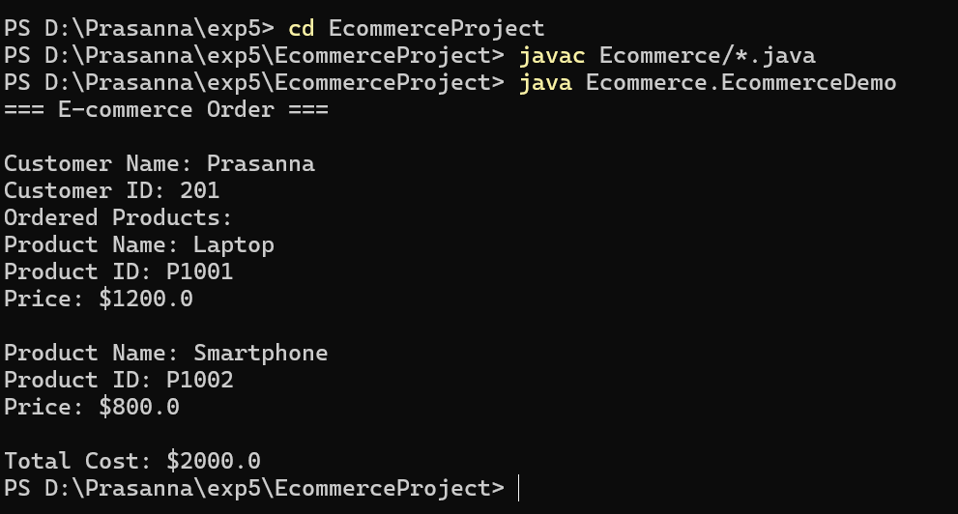
3. Create a package named MathOperations that contains classes for mathematical functions like floor, round, and ceil. Implement a program that uses these functions to perform operations on different numbers. (The Math class in Java contains the methods floor(), ceil(), and round())

MathProject/
└── MathOperations/
├── Floor.java
├── Ceil.java
├── Round.java
└── MathDemo.java

//Floor.java
package MathOperations;
public class Floor {
public double compute(double num) {
return Math.floor(num);
}
}

// Ceil.java
package MathOperations;
public class Ceil {
public double compute(double num) {
return Math.ceil(num);
}
}

// Round.java

package MathOperations;
public class Round {
public long compute(double num) {
return Math.round(num);
}
}

// MathDemo.java

package MathOperations;
public class MathDemo {
public static void main(String[] args) {
double num1 = 12.7;
double num2 = 5.3;
Floor f = new Floor();
Ceil c = new Ceil();
Round r = new Round();
System.out.println("Number 1: " + num1);
System.out.println("Floor: " + f.compute(num1));
System.out.println("Ceil: " + c.compute(num1));
System.out.println("Round: " + r.compute(num1));
System.out.println("\nNumber 2: " + num2);
System.out.println("Floor: " + f.compute(num2));
System.out.println("Ceil: " + c.compute(num2));
System.out.println("Round: " + r.compute(num2));
}
}

